Stationery list 2024 - Te Pouahi tau 5,6

This year we are partnering with Warehouse Stationery, who will donate a $20 voucher to the school for every 5 packs bought.

They have all stationery packs ready for you to pick up in the Nelson store (at The Warehouse)

or you can order online at www.warehousestationery.co.nz
Select ‘Lists’, then search ‘Nelson Central School’ and select the Room number.

If ordering online, you can delete items you already have from the list or add any individual items as you like.
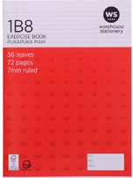  7 x 1B8  1 x Pānui  1 x Tuhituhi  1 x Expressive Diary/Goals  1 x Inquiry  1 x Te Reo Māori  2 x spare | 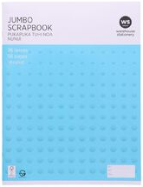  1 x NOT lined scrapbook large Size (Art) | 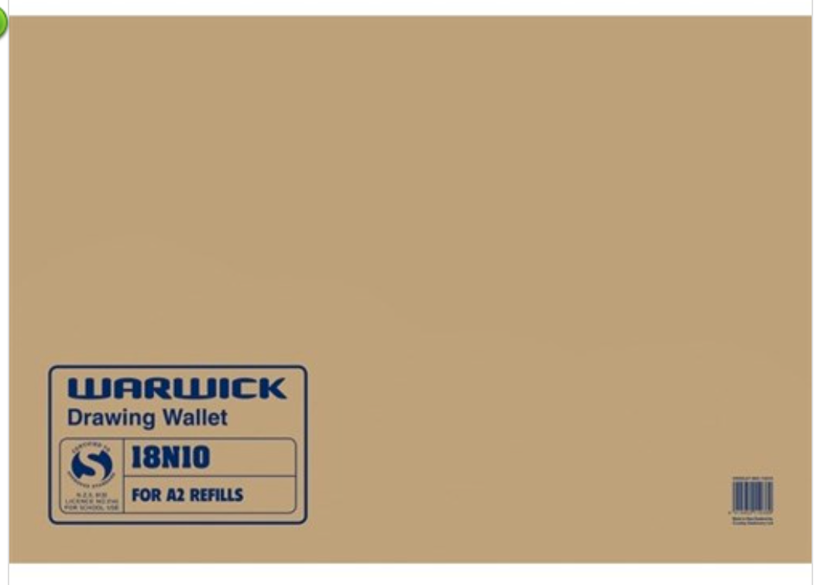  Drawing wallet - 18N10  Year 5/6’s can continue using the one in class from last year.
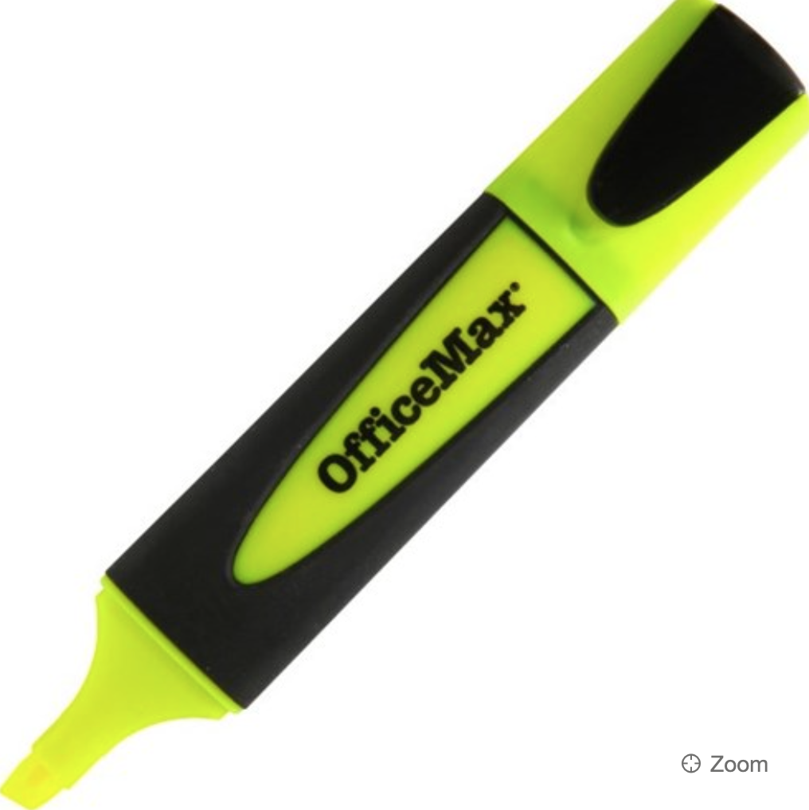  2 x highlighter  NAME ALL PLEASE | 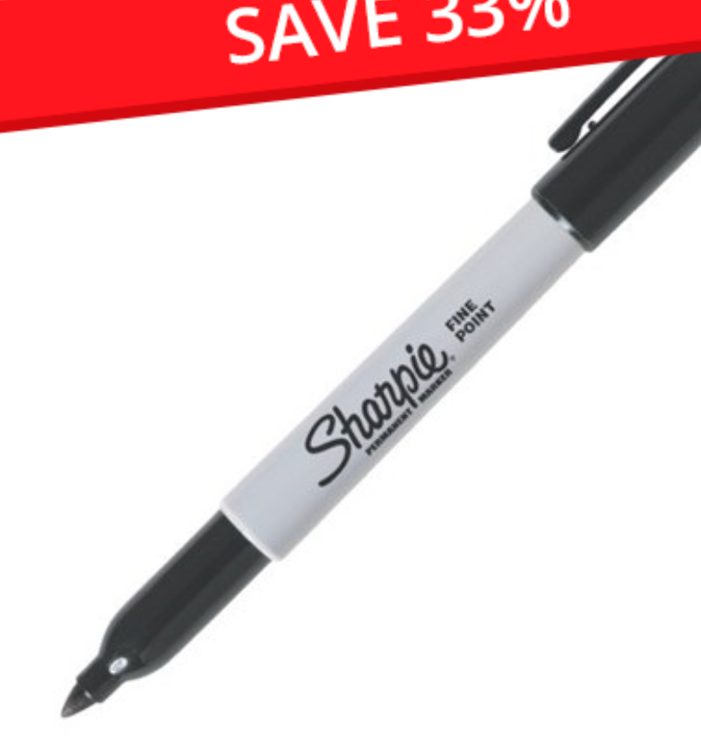  1 x sharpie  NAME ALL PLEASE | 4 x Blue or Black Biro  NAME ALL PLEASE
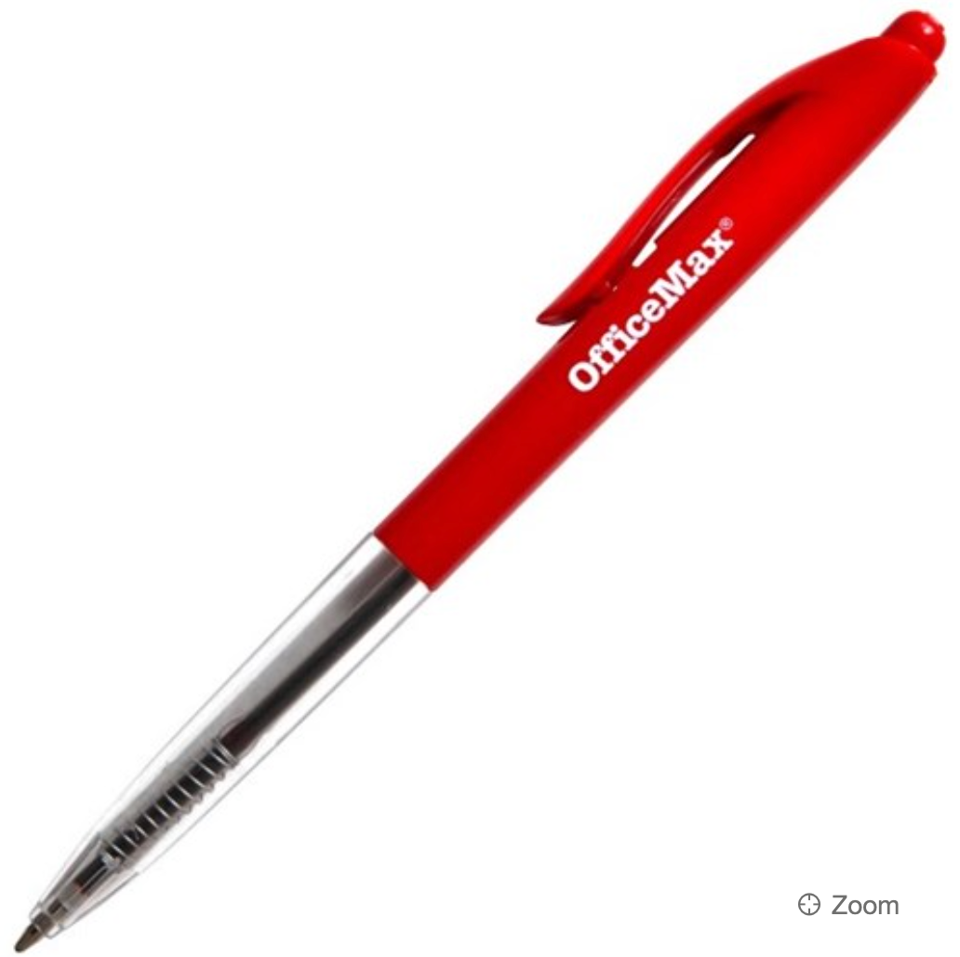  2 x Red Biro  NAME ALL PLEASE | 2 x Glue stick - Not named  (These are all shared as a class) | 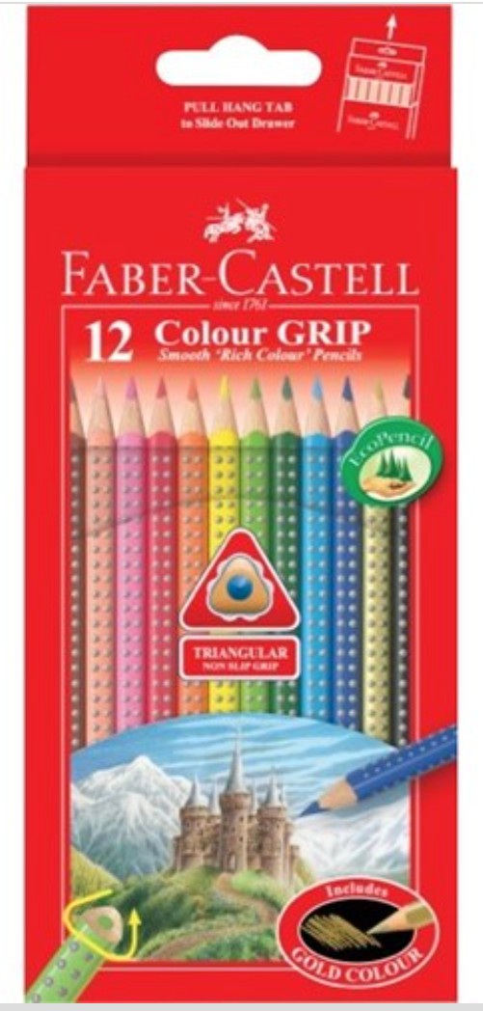  1 x Quality pack of colouring pencils  *** PLEASE NAME INDIVIDUAL
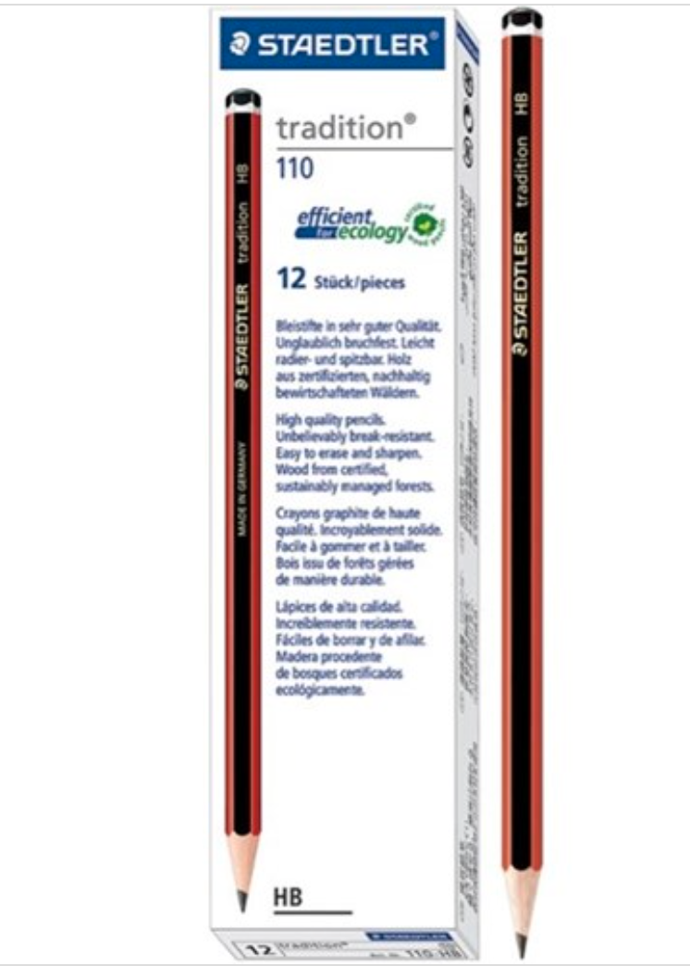  4 x pencils (HB)  NAME ALL INDIVIDUAL PENCILS PLEASE | 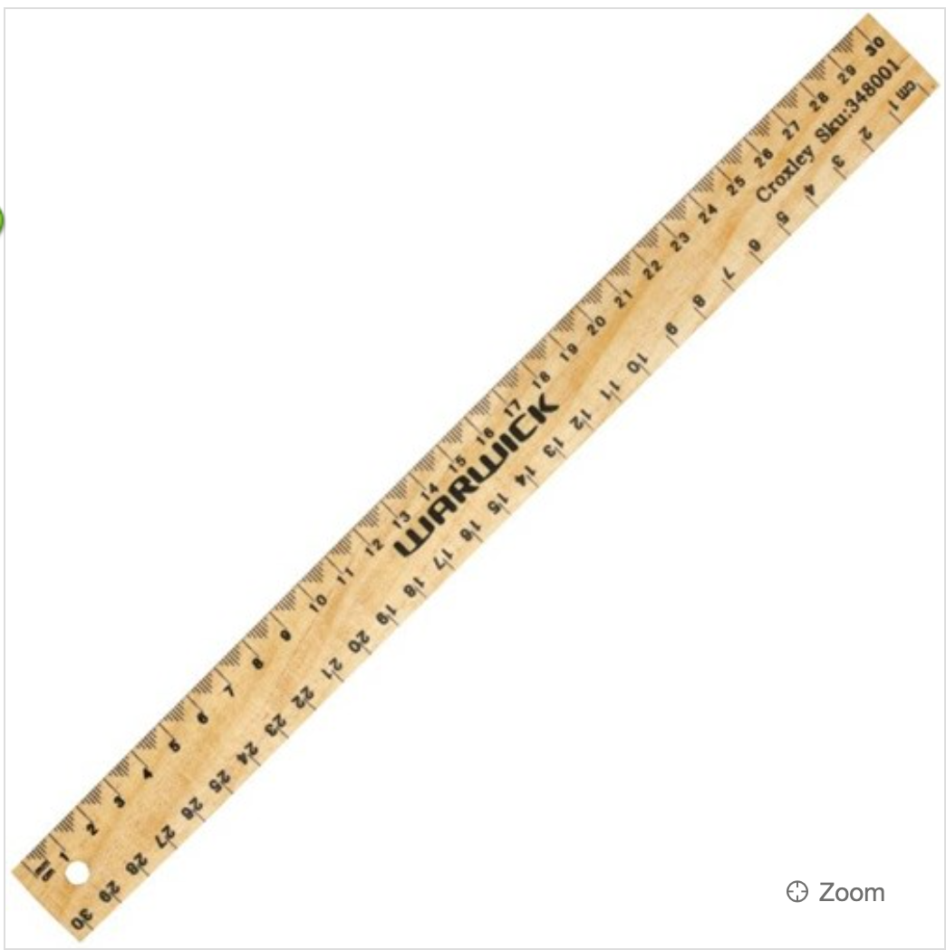  1 x ruler  NAMED | 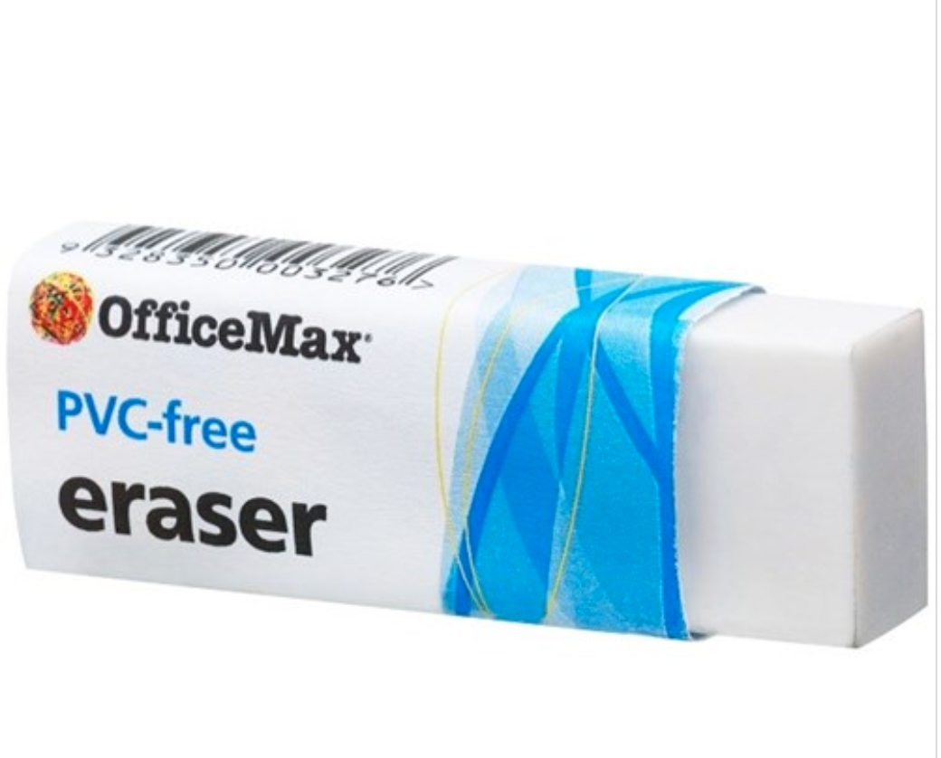  2 x Rubbers  (These are all shared as a class)
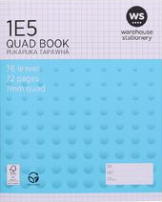  1 x 1E5 Maths books - preferably with margins ruled. | 1 x box of tissues (optional) | 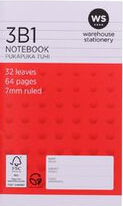  1 x NB notebook

This year we are partnering with Warehouse Stationery, who will donate a $20 voucher to the school for every 5 packs bought.

They have all stationery packs ready for you to pick up in the Nelson store (at The Warehouse)

or you can order online at www.warehousestationery.co.nz
Select ‘Lists’, then search ‘Nelson Central School’ and select the Room number.

If ordering online, you can delete items you already have from the list or add any individual items as you like.

