Kahikatea Stationery list 2024 - Room 8

This year we are partnering with Warehouse Stationery, who will donate a $20 voucher to the school for every 5 packs bought.

They have all stationery packs ready for you to pick up in the Nelson store (at The Warehouse)

or you can order online at www.warehousestationery.co.nz
Select ‘Lists’, then search ‘Nelson Central School’ and select the Room number.

If ordering online, you can delete items you already have from the list or add any individual items as you like.

3 x 1I5 / 1WB (9mm ruled) exercise books  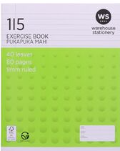  Reading  Spelling/Handwriting  Writing | 1 x My Maths quad Book  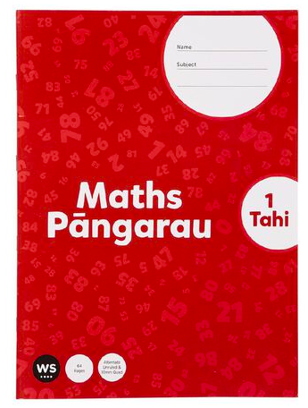 | 1 x Topic Book  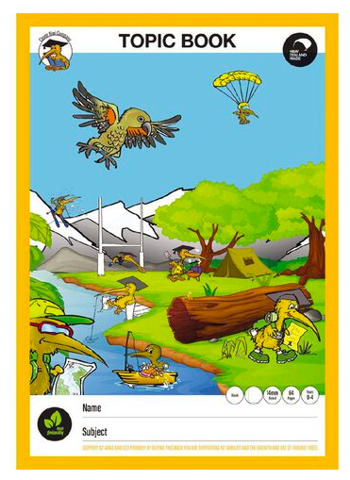 | 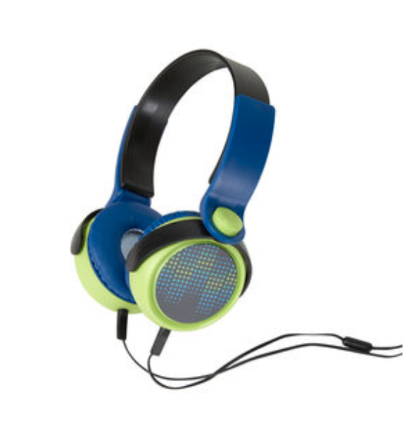  1 x headphones - these do not need to be flash or top of the line.
2 x Large AMOS Glue Sticks (named)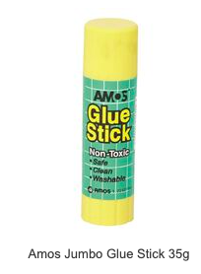 | 8 x HB Pencils  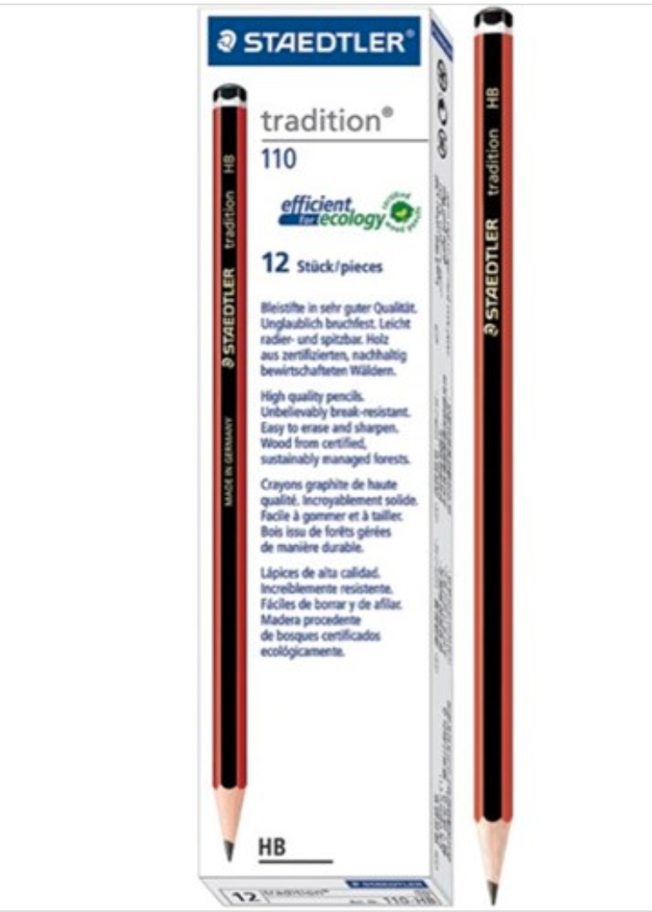 | 2 x Rubbers  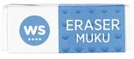 | 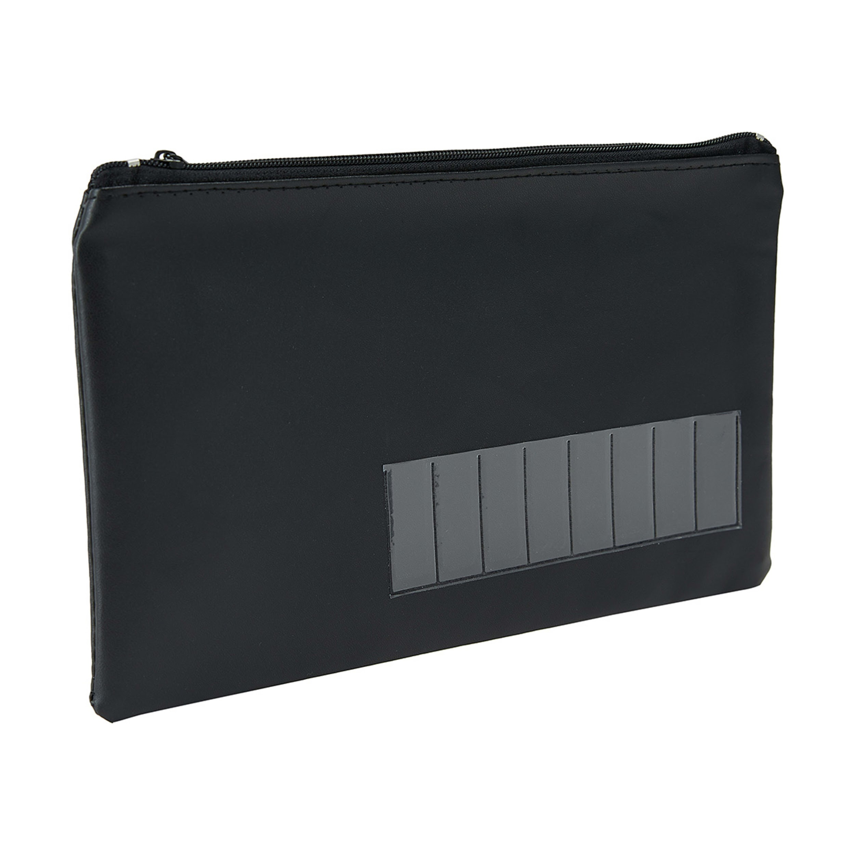  1 x Pencil case
1 x Ruler (named)  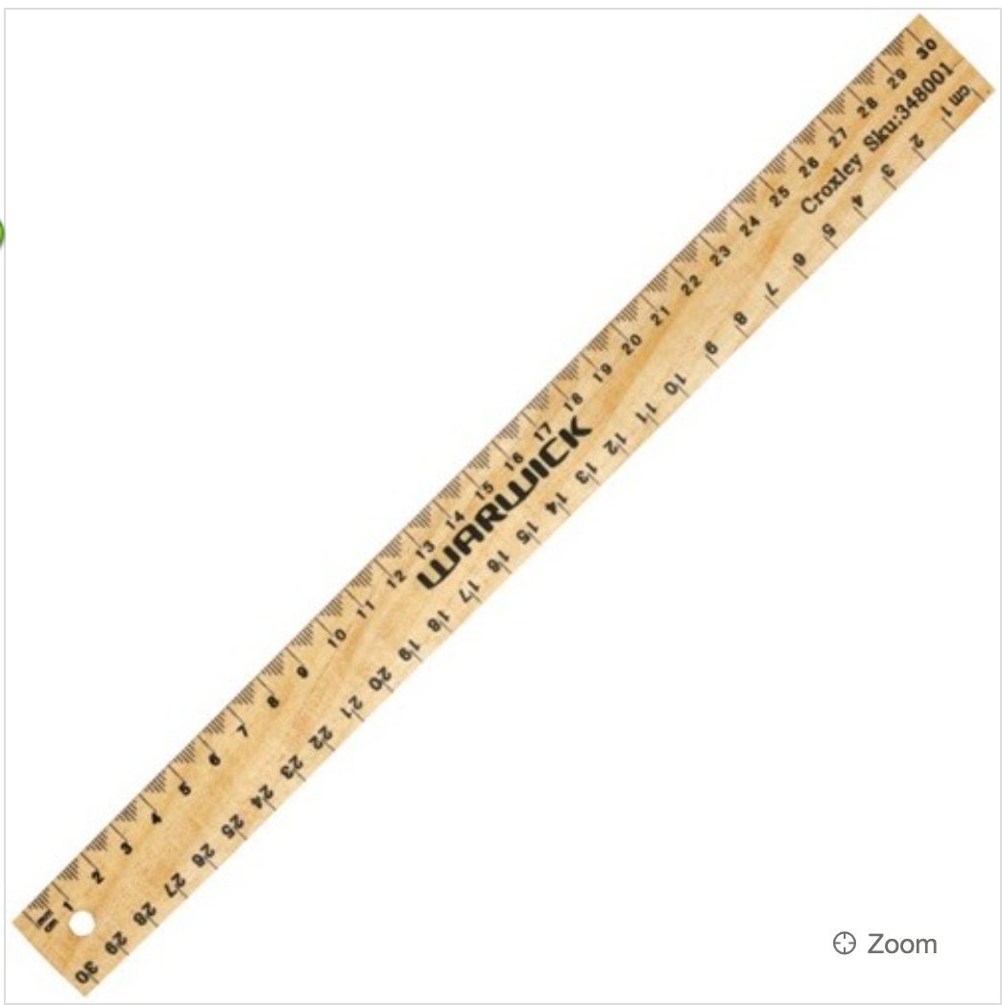 | 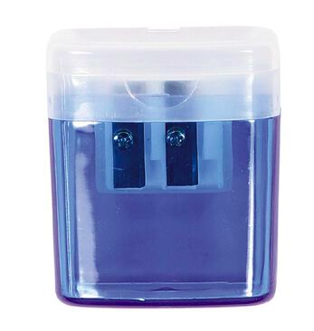  1 x Pencil sharpener | 1 x 12 pkt of quality coloured pencils  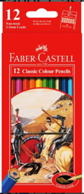 | 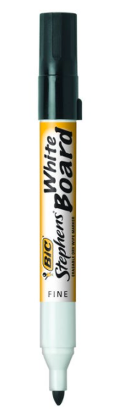  2 x Black Whiteboard Markers
A named, wide-brimmed sun hat.
(Available from the school office and cost $16.00)