Tōtara Stationery list 2024 Rooms 1,2,3,4

This year we are partnering with Warehouse Stationery, who will donate a $20 voucher to the school for every 5 packs bought.

They have all stationery packs ready for you to pick up in the Nelson store (at The Warehouse)

or you can order online at www.warehousestationery.co.nz
Select ‘Lists’, then search ‘Nelson Central School’ and select the Room number.

If ordering online, you can delete items you already have from the list or add any individual items as you like.
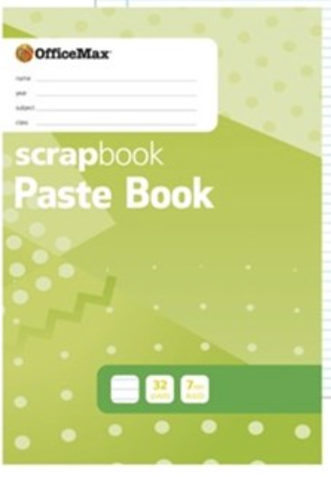  1 x lined scrapbook  (Inquiry) | 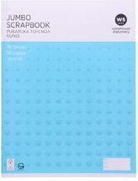  1 x NOT lined scrapbook  (Art) | 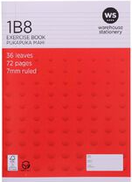  5 x 1B8  1 x Reading  2 x Writing  1 x Spelling/handwriting  1 x Spare (give to Teacher)
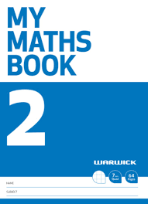  1x My Maths Book 2 (7mm Quad 64 Pages) | 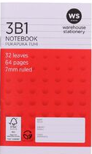  1x 3B1 Notebook (Vocab/Spelling) | 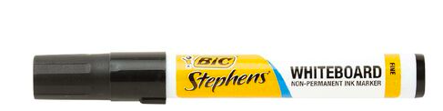  2x whiteboard marker black or blue
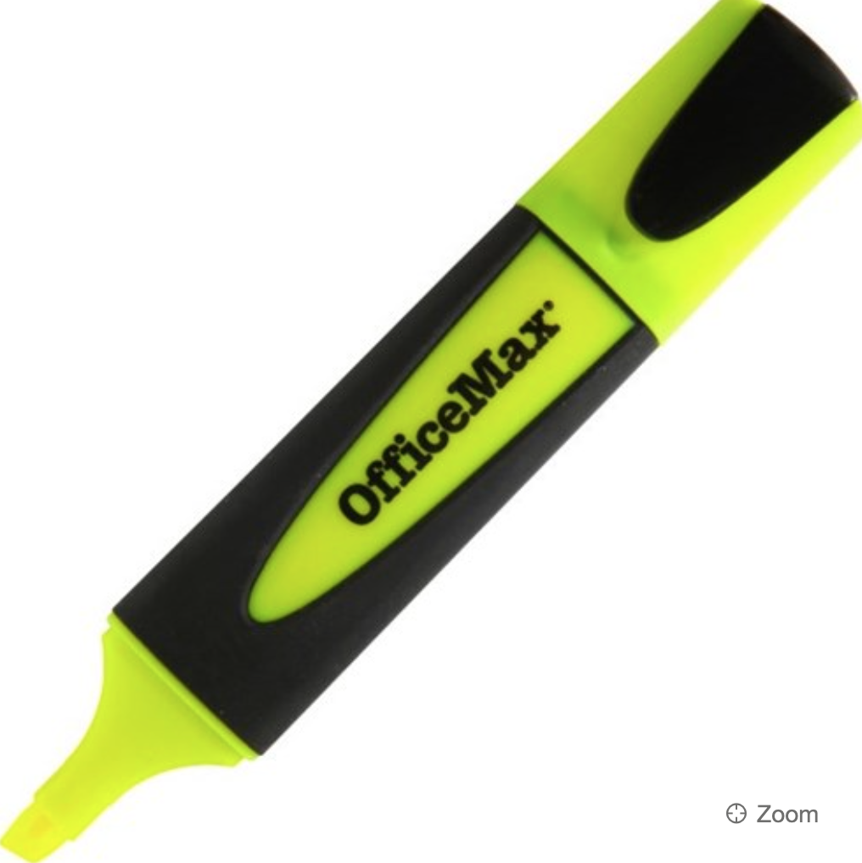  2 x highlighter - different colours | 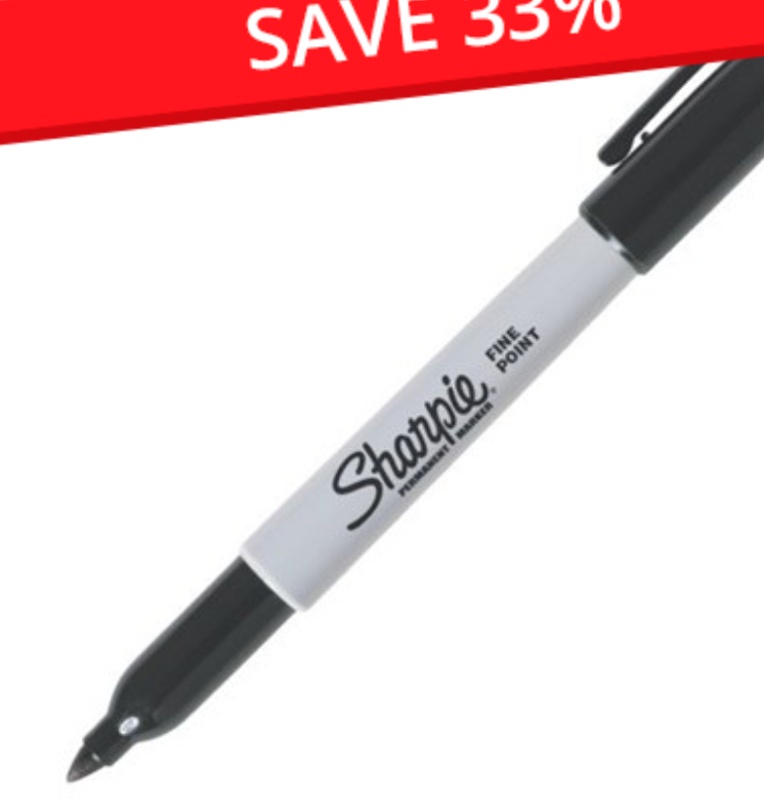  2 x sharpie | 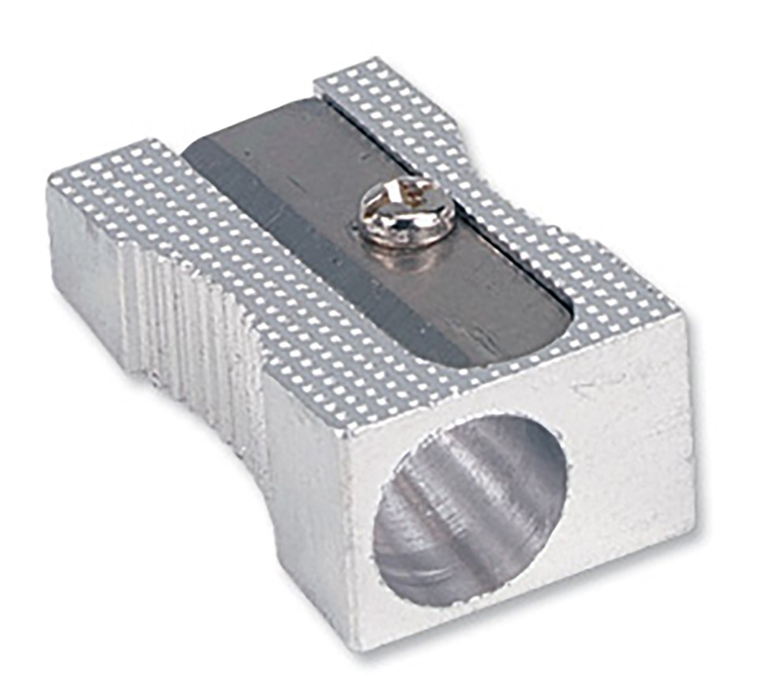  1x metal sharpener
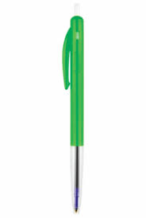  2 x green biro | 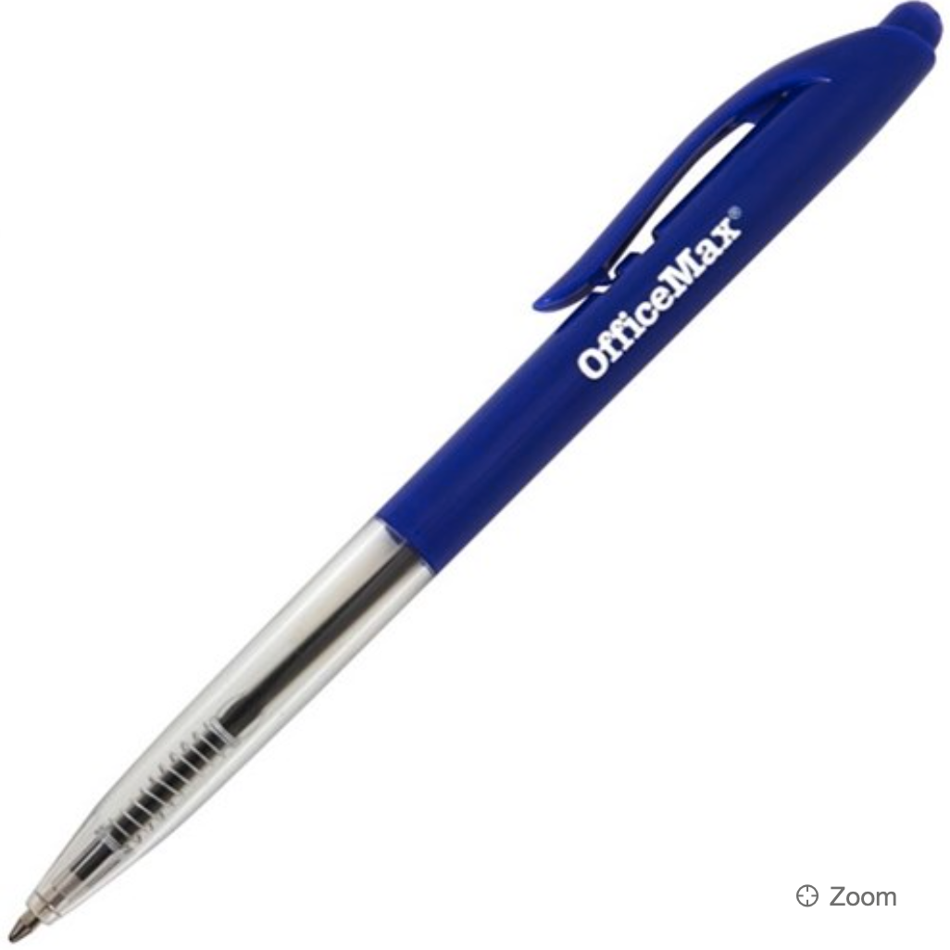  1 x Blue Biro | 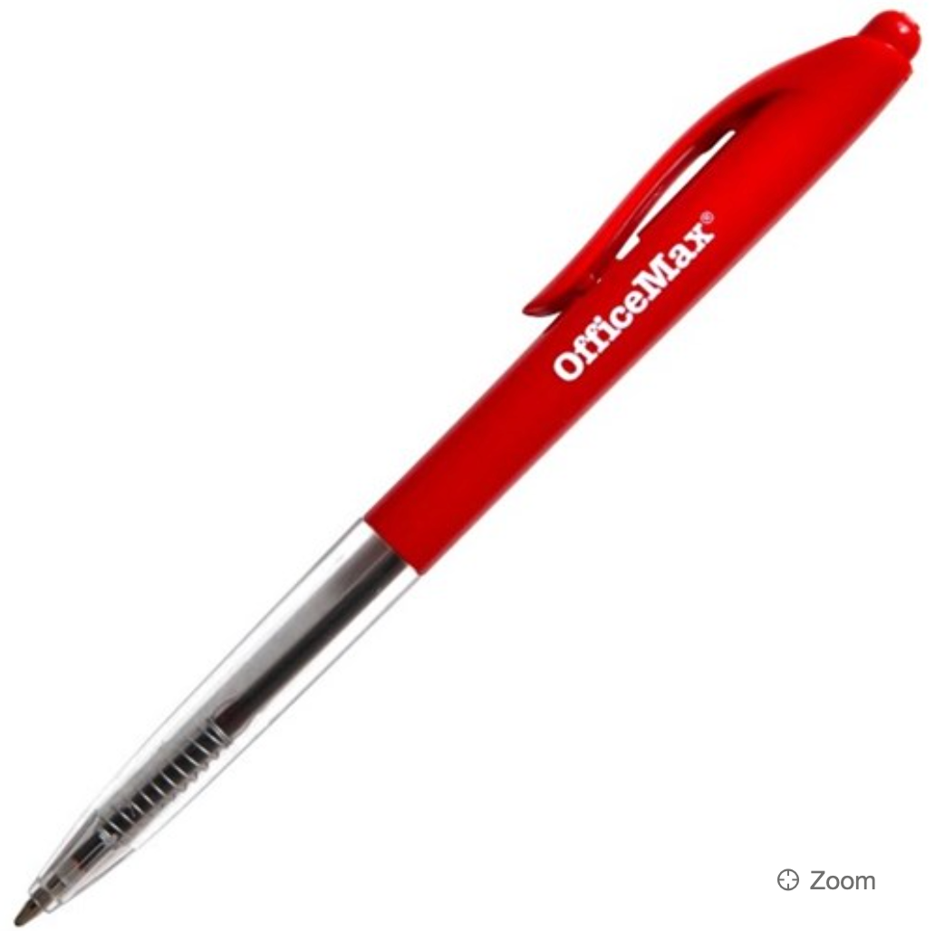  2 x Red Biro
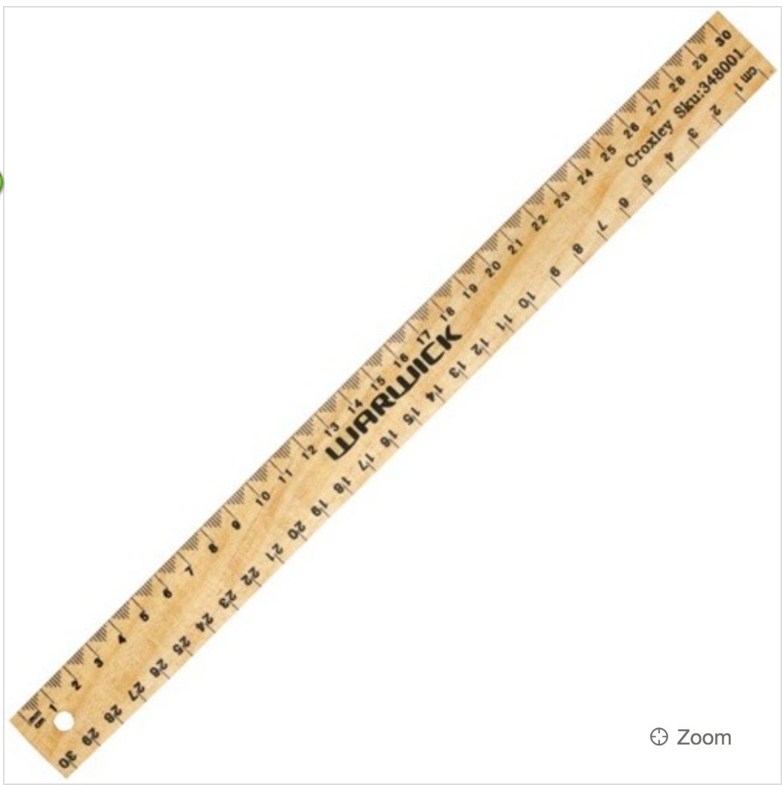  1 x wooden/metal ruler (not plastic - short lifespan) | 3 x Glue stick -  ( 1 for their pencil case - named and 2 to be shared as a class, no name) | 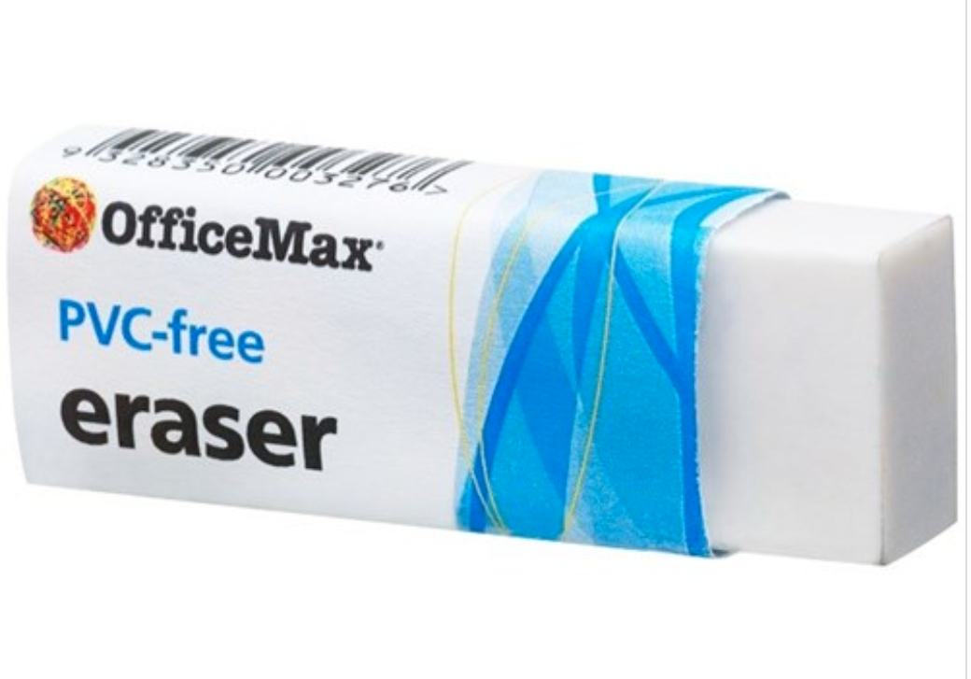  2 x Rubbers (one named)  (One will be kept in a bag and the other in the pencil case)
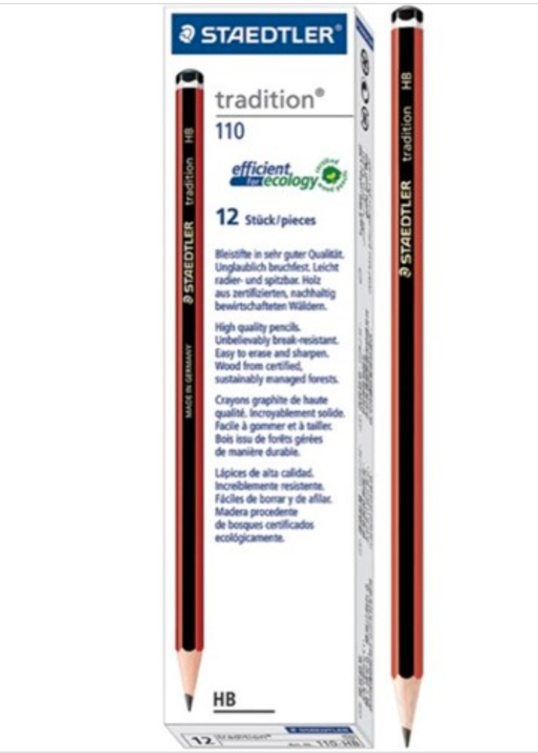  10 x pencils (2 in pencil case, others will be kept in a box) | 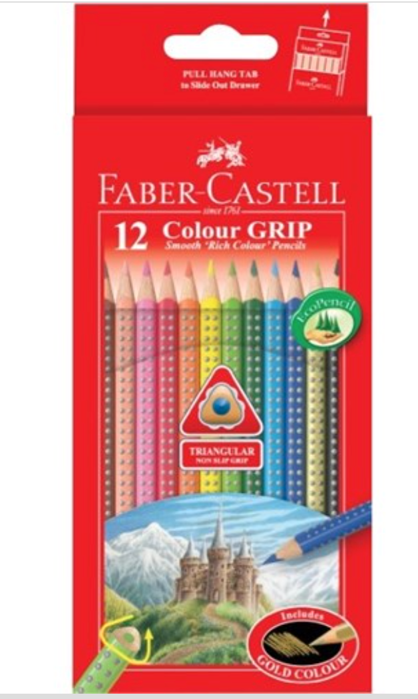  1 x Quality pack of colouring pencils | 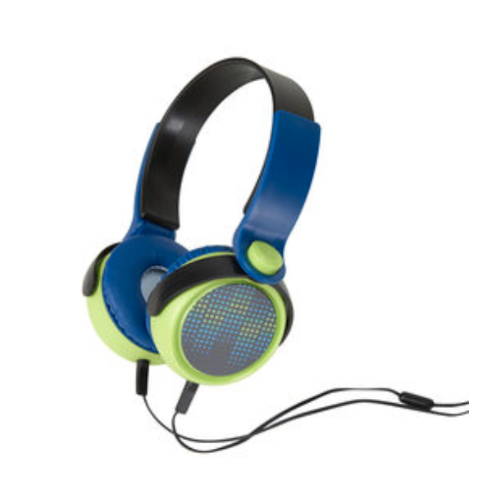  1 x headphones -  **earbuds are broken easily**  Cheaper options from Kmart - these do not need to be flash or top of the line.
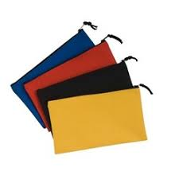  SMALL pencil case | Please ensure your child’s books have a name on them. | 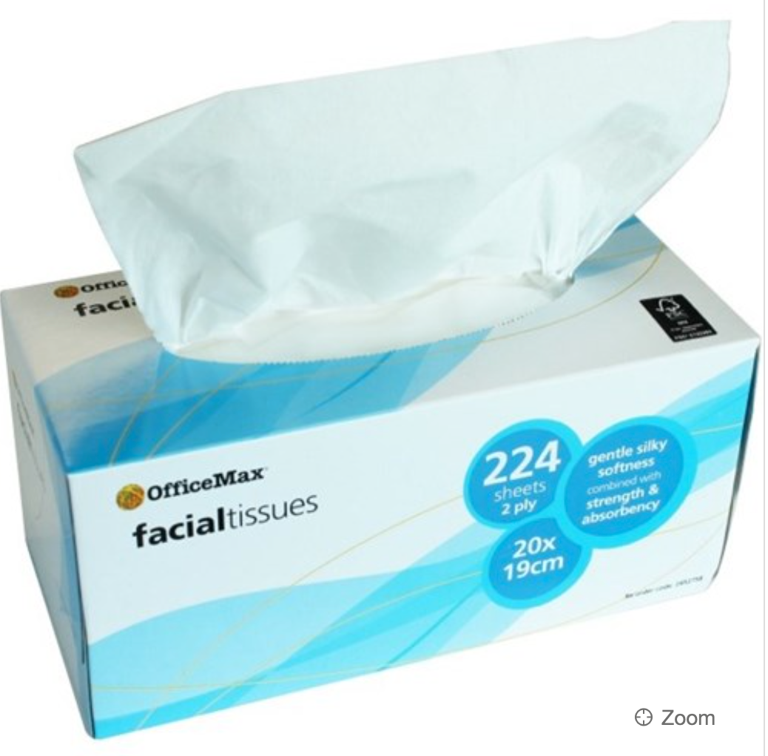  1 x box of tissues

